**EXPERIMENT NO : 04 DATE : 05/03/24**

**Aim**: To implement the 8-Puzzel problem using Hill Climb Search

**Theory**:

It has set off a 3x3 board having 9 block spaces out of which 8 blocks having tiles bearing number from 1 to 8. One space is left blank. The tile adjacent to blank space can move into it. We have to arrange the tiles in a sequence for getting the goal state. The 8-puzzle problem is invented and popularized by Noyes Palmer Chapman in the year 1870. It is played on a 3-by-3 grid with 8 square blocks/tiles labelled 1 through 8 and a blank square. The goal of this 8-puzzle problem is to rearrange the given blocks in the correct order. The tiles can be shifted vertically or horizontally using the empty square. We also know the eight-puzzle problem by the name of N puzzle problem or sliding puzzle problem. N-puzzle that consists of N tiles (N+1 titles with an empty tile) where N can be 8, 15, 24 and so on. In our example N = 8. (that is, square root of (8+1) = 3 rows and 3 columns). In the same way, if we have N = 15, 24 in this way, then they have Row and columns as follow (square root of (N+1) rows and square root of (N+1) columns). That is if N=15 than number of rows and columns= 4, and if N= 24 number of rows and columns= 5. So, basically in these types of problems we have given an initial state or initial configuration (Start state) and a Goal state or Goal Configuration. Here We are solving a problem of 8 puzzle that is a 3x3 matrix.

**Algorithm:**

Hill Climb

node = start

newnode = head(sortn(movegen(node)))

while h(newnode) > h(node) do

node = newnode

newnode = head(sortn(movegen(node)))

//end of while

return newnode

**Example:**



**Code:**

#case that terminats hill climbing due to failed case

# start_state = [[1, 2, 3],

# [4, 5, 6],

# [7, 8, 0]]

# goal_state = [[1, 2, 3],

# [8, 0, 4],

# [7, 6, 5]]

#successfull case

start_state = [[1, 2, 3],

[5, 6, 0],

[7, 8, 4]]

goal_state = [[1, 2, 3],

[5, 8, 6],

[0, 7, 4]]

def print_state(state):

for row in state:

print(row)

def get_blank_position(state):

for i in range(3):

for j in range(3):

if state[i][j] == 0:

return i, j

def gen_moves(state):

moves = []

i, j = get_blank_position(state)

if i == 0:

if j == 0:

moves.append((i, j + 1))

moves.append((i + 1, 0))

elif j == 1:

moves.append((i, j - 1))

moves.append((i, j + 1))

moves.append((i + 1, j))

elif j == 2:

moves.append((i, j - 1))

moves.append((i + 1, j))

elif i == 1:

if j == 0:

moves.append((i, j + 1))

moves.append((i - 1, j))

moves.append((i + 1, j))

elif j == 1:

moves.append((i, j - 1))

moves.append((i, j + 1))

moves.append((i + 1, j))

moves.append((i - 1, j))

elif j == 2:

moves.append((i, j - 1))

moves.append((i + 1, j))

moves.append((i - 1, j))

elif i == 2:

if j == 0:

moves.append((i - 1, j))

moves.append((i, j + 1))

elif j == 1:

moves.append((i, j - 1))

moves.append((i, j + 1))

moves.append((i - 1, j))

elif j == 2:

moves.append((i, j - 1))

moves.append((i - 1, j))

return moves

def make_move(state, moves):

i, j = get_blank_position(state)

states = []

for new_i, new_j in moves:

current = [row[:] for row in state]

current[i][j], current[new_i][new_j] = current[new_i][new_j], current[i][j]

states.append(current)

return states

def manhattan_distance(state, goal_state):

total_distance = 0

# Create dictionaries to store the position of each number in the goal state

goal_positions = {}

for i in range(3):

for j in range(3):

goal_positions[goal_state[i][j]] = (i, j)

# Calculate Manhattan distance for each tile in the current state

for i in range(3):

for j in range(3):

if state[i][j] != 0: # Ignore the empty tile

num = state[i][j]

goal_pos = goal_positions[num]

distance = abs(i - goal_pos[0]) + abs(j - goal_pos[1])

total_distance += distance

return total_distance

def hill_climbing(start):

current_state = start

print("Initial State: ")

print_state(current_state)

if start_state == goal_state:

print("Goal reached")

prev_heuristic = None

while True:

moves = gen_moves(current_state)

next_states = make_move(current_state, moves)

min_heuristic = float('inf')

next_state = None

for state in next_states:

heuristic = manhattan_distance(state, goal_state)

if heuristic < min_heuristic:

min_heuristic = heuristic

next_state = state

if prev_heuristic is not None and min_heuristic >= prev_heuristic:

print("No better state found. Terminating.")

break

prev_heuristic=min_heuristic

if min_heuristic > 0:

current_state = next_state

print("Next State: ")

print_state(current_state)

print("Heuritic value = "+ str(min_heuristic))

else:

print("Goal state found.")

print("Final state: ")

print_state(goal_state)

break

hill_climbing(start_state)

**Output:**

**Successful case**

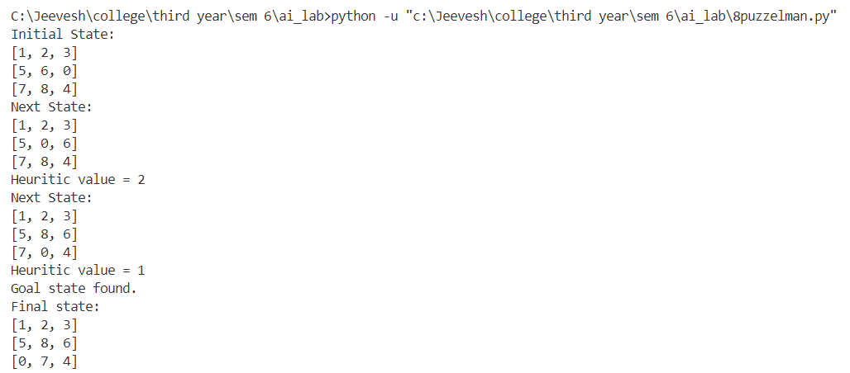

**Failed case**

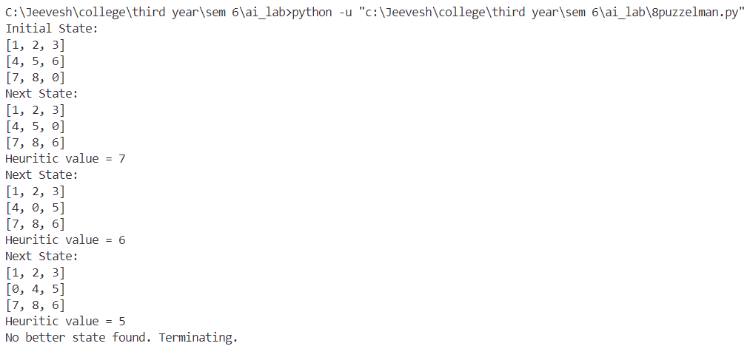

**Conclusion:**

Implementation of the 8 Puzzles Problem Using Hill Climb Search was carried out by tracing the algorithm and above output was obtained during the same.